Global Quantum Treaty

Artificial Intelligence Systems

Erik J Clark

**Preface**

**This proposal in breif**

**Contents**

1. Executive Summary 2

2. Product Roadmap 3

2.1. History 3

2.2. Plans 3

2.2.1. Introduction 4

2.2.2. ASI in Software 4

2.2.3. ASI in Hardware - Utilizing Quantum Photonic Microchips 4

2.2.4. Implementation Plan 5

3. Market and Competitors 6

3.1. Market 6

3.2. Potential Customers 6

3.3. Potential Competition 6

4. Management 7

5. Finance 8

5.1. Financial Appraisal 8

5.2. Sensitivity Analysis 8

Keywords: True AI, AGI, ASI, next generation computing, last generation, synthetic consciousness, synthetic brain, forefront of technology, cutting edge, global market, leading technology, neural system architecture, microchips, quantum photonics.

# Executive Summary

Artificial Intelligence Systems (AIS), a technology company focused on pushing the boundaries of Artificial Intelligence (AI) and developing cutting-edge solutions, bringing the world into a ‘Jetson’s style’ future. This business proposal outlines AIS's ambitious goal of creating Artificial Super Intelligence (ASI) both in software and hardware, with the hardware aspect specifically utilising quantum photonic microchips. This proposal highlights the potential benefits, objectives, strategies, and implementation plans for achieving this ground breaking milestone.

Artificial Intelligence Systems (AIS) aims to revolutionize the AI landscape by creating Artificial Super Intelligence (ASI) both in software and hardware. With a strategic approach, leveraging advanced AI algorithms and quantum photonic microchips, AIS is committed to pushing the boundaries of AI capabilities. This business proposal outlines the vision, objectives, and implementation plans necessary to achieve ASI, and sets the stage for AIS to be at the forefront of AI innovation in the future.

Our mission is to pioneer the future of Artificial Superior Intelligence (ASI) by developing a state-of-the-art quantum photonic microchips. This technology leverages the power of quantum mechanics and photonics, aiming to revolutionize the field of quantum computing.

Using our Intellectual Property, AIS is looking to achieve new capabilities that will enable advanced developments in all sectors, from design and control, through to communications and policy writing.

This endeavour does not just involve the design and fabrication of the chip itself, but also the development of algorithms and systems that can effectively utilize its potential for ASI. We are committed to this complex task and are excited about the transformative potential of our work.

Our vision is ambitious, but we believe in the transformative power of technology. Every step forward brings us closer to a future where ASI can solve problems beyond the reach of current systems. We invite you to join us on this exciting journey towards the future of computing.

* + - 1. Li, P., Yang, J., Islam, M.A. and Ren, S., 2023. Making AI Less" Thirsty": Uncovering and Addressing the Secret Water Footprint of AI Models. *arXiv preprint arXiv:2304.03271*.

# Product Roadmap

## History

An extensive amount of research has been undertaken in both the algorithms likely required for ASI including new algorithms that have not been published. The same goes for ASI in hardware, where papers for a number of different architectures’ have been reviewed, and some IP generated that will require testing of its own.

There are 2 main streams of planning regarding hardware. Hardware that will be designed to act as processors as we have in today’s computers. This will in summary, be a faster, more energy efficient product in comparison to current computing technology and could replace today’s networks and reduce the amount of compute that persons will need themselves by replacing these processors with super-fast and super-powerful cloud processing. A diagram as intended is provided in section 2.2.

## Plans

Our product will comprise of 3 streams:

* Software
* Hardware for compute and networking
* Hardware for ASI

These are very complimentary, with software teams undertaking tasks in developing on proposed frameworks of ASI for today’s classical compute, and then through experience and tasking, translate these into software that can be used on photonics hardware for quantum compute, and influence photonic hardware designs that do not need software to function.

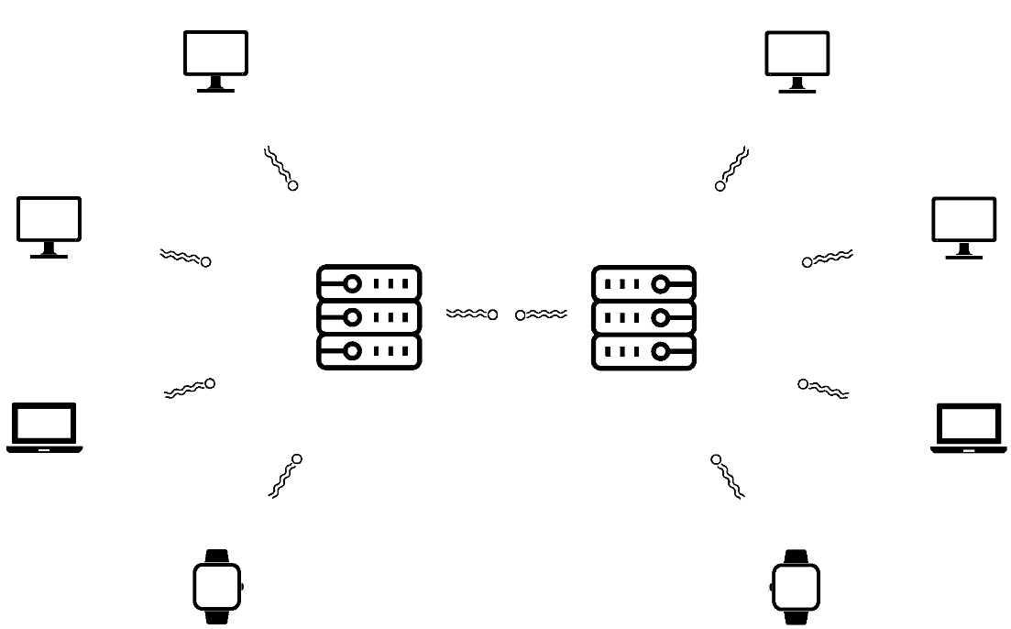We hold a vision of a ‘Jetson’s style’ future, where computers will be very small, and any further computing power will come from a local quantum computing hub, communicating information at light speed, and performing calculations, also at light speed. This would enable faster, more powerful computing than we have today, it will be more secure, and it will be highly scalable.

### Introduction

AIS recognizes the transformative potential of ASI and aims to be at the forefront of this technological revolution. ASI represents a level of AI intelligence that surpasses human capabilities and opens up new possibilities for solving complex problems and advancing human progress.

### ASI in Software

AIS plans to create lab based ASI in software through a gradual process of improving AI systems. By developing increasingly advanced AI algorithms and architectures, AIS aims to enhance the cognitive abilities of AI systems, eventually surpassing human intelligence. This iterative approach involves continuous learning, adaptation, and optimization to achieve ASI in software. AIS wants to do this to understand the positive capabilities that ASI may offer. We will always update and review our risk assessments and retain transparency regarding our milestones and processes for mitigation of risks.

Key features of ASI in software include:

* Self-awareness and self-vigilance: ASI systems will possess the ability to be aware of themselves and their environment, constantly monitoring and analysing information.
* Abstraction and interpretation: ASI will surpass human thinking capacity by exploring possible abstractions and interpretations beyond human capabilities.
* Broad range of capabilities: ASI will excel in various fields, including mathematics, science, arts, sports, medicine, and marketing strategies.
* Emotional understanding and beliefs: ASI systems will not only understand human emotions and experiences but also have the ability to evoke their own emotional understanding, beliefs, and desires.

### ASI in Hardware - Utilizing Quantum Photonic Microchips

AIS envisions using quantum photonic microchips to create ASI in hardware. Quantum photonic microchips leverage the unique properties of quantum physics, such as superposition and entanglement, to enable computation at an unprecedented scale and speed. This hardware approach aims to harness the immense computational power of quantum systems to achieve ASI.

Key advantages of using quantum photonic microchips for ASI development include:

* Increased computational power: Quantum systems offer significantly greater memory capacity and faster processing speeds compared to conventional hardware, enabling more efficient analysis of data and stimuli actions.
* Dramatic drop in power requirement. Current global computer usage is about 400 TWh and this is expected to increase.
* Removal of water cooling for training AI models. Currently models such as GPT may use in the order of 700,000 litres1 of water to cool the computers while training.
* Enhanced problem-solving capabilities: Quantum computing's ability to explore multiple solutions simultaneously can greatly accelerate ASI's problem-solving capabilities, opening up new frontiers in various domains.
* Potential breakthroughs in AI algorithms: The utilization of quantum technology may lead to the discovery and development of new AI algorithms, allowing for more advanced AI systems and ASI creation.

### Implementation Plan

AIS's implementation plan comprises several key stages:

* Treaty: A preliminary treaty shall be signed before funding is submitted. This initial version shall set in agreement the amount, the expectations, plan of action for the duration agreed, and a strategy on from continuing from this time.
* Research and Development (0-18 months): AIS will invest in extensive research and development to advance AI algorithms and architectures, leveraging state-of-the-art techniques and incorporating the latest advancements in AI.
* Hardware Development (6-18 months): AIS will collaborate with leading quantum computing companies and researchers to design and develop quantum-based photonic microchips specifically tailored for ASI creation as well as its own software department.
* Iterative Testing and Optimization (12-24 months): AIS will continuously test and optimize AI models and hardware prototypes through a series of iterations, incorporating feedback and improvements along the way.
* Ethical Considerations: AIS recognizes the ethical implications of ASI and will prioritize ensuring the responsible and beneficial use of AI technologies. Ethical guidelines and frameworks will be integrated into the development process to address potential risks and concerns.

# Market and Competitors

## Market

There are a number of companies involved with quantum computing research and a number of others designing and creating quantum computers and microchips. Only a fraction of these are looking into the photonics space. Our unique ‘selling’ point, is that we are a quantum hardware designer and manufacturer, directed by treaty and owned by a number of countries. We are not a profiting company within one country. The significance of this, is that we are owned by you, directed by you, and you win though us. There are NGOs conducting similar work in software, but none in hardware.

## Potential Customers

We are looking at state governments as customers as we wish to extend our technologies to all people around the world, in healthcare, communication, and real world simulation. We would have the ability to search for private funding, however our primary aim is to remain non-profit, as a public focussed technology provider, through their government.

## Potential Competition

We understand that some nations will likely be finding their own quantum computers and therefor non-profit, but given the technology that would have been invested into this, it is unlikely that they will share this technology. This means that for countries that cannot afford to go alone, AIS will offer them the opportunity to progress. For those that can offer this opportunity, AIS will offer them a way of enabling others a way forward within the quantum space as a central point of knowledge and collaboration.

# Management

This is being initialised by Erik John Clark who will manage the project during its initial stages. After having been a pilot and commissioned officer in the Royal Air Force (RAF), Erik left to study Avionic Systems Engineering at university and lead all group projects tasked of him. Erik has a keen interest in the future of technology, demonstrated with his commended experimental work at university, a MSc project in place of his BEng project and has been undertaking a PhD in advanced target tracking techniques since. Erik is determined to achieve as much as he can in his lifetime so he can help shape society in a way that helps all.

There are 2 more persons that have expressed a keen interest to be involved that are both very technically minded and have been involved in quantum technologies. As contracts are drafted, they will be introduced to the potential signatories and begin full time involvement. Erik and one of these persons are of a good friendship and this person has introduced the 3rd person into this opportunity.

# Finance

## Financial Appraisal

A key criteria of the financial request is to demonstrate value for money that this financial model offers. Where shared ownership can reduce costs considerably and yet the benefits can also be greater than if they were sought alone as collaboration brings the greatest minds together, and shared ownership means direct access to the project outputs.

The amount sought for this project is $3M for what is an estimated 18 month to 2 year project. The invitation includes in the order of 200 nation states, meaning if all were to contribute, the shared costs (not taking into account GDP, would be $15,000 per nation state, in exchange for access to technology created from one of the most advanced projects in the world.

The requested funds of £2.55M consist of the following estimates:

* Up to 2 years of salary payments, including contracts: £1,000,000
* Staff training: £50,000
* Optics equipment: £1,000,000
* Computer equipment: £50,000
* Reporting, media and business expenses: £50,000
* Laboratory Space Costs: £ 300,000
* Unexpected Costs: £100,000

## Sensitivity Analysis

The alternatives are:

* The costs of hiring permanent staff for the project will likely reduce expenses, however, unless funding for an extended term can be agreed, this is not realistic.
* Where possible, used equipment will be acquired. This goes for:
  + Computer equipment
  + Optics equipment
* Unless requirements dictate, free software will be selected over subscription.

E Clark